November 23, 2013
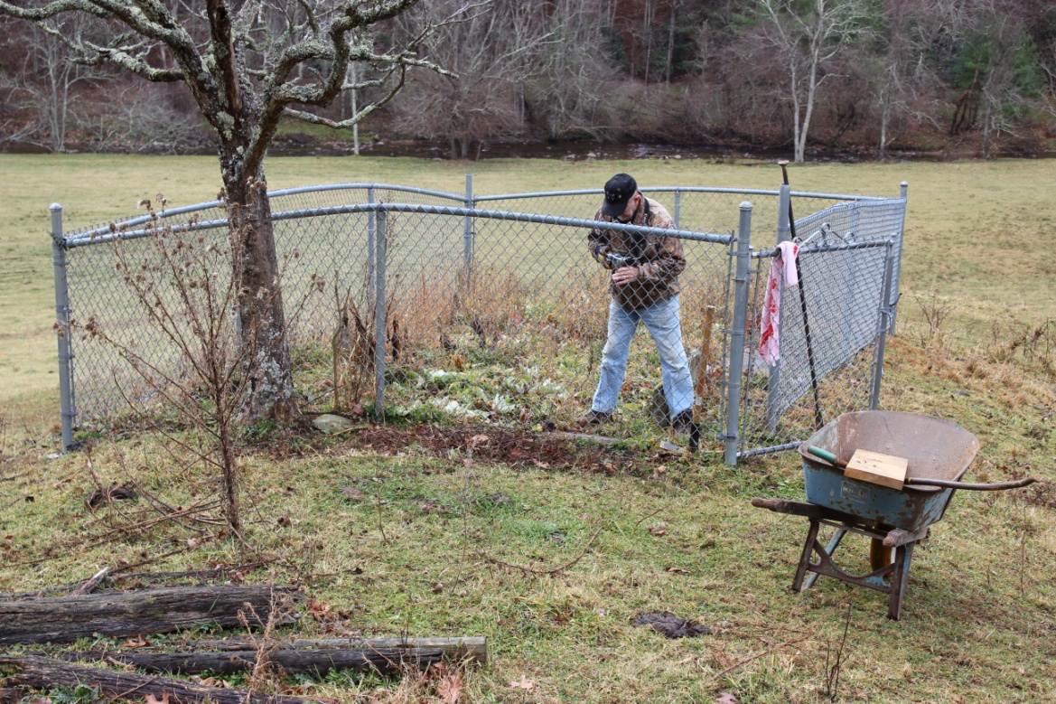
Andy Anderson, surveys the marker in the John Anderson Family Cemetery behind the Garnett Anderson house. Two brass markers on stone bases were placed in the cemetery soon after the chain link fence was erected in the late 1970’s or early 1980’s. This small cemetery contains the graves of John Anderson (son of Jacob), John’s wife, Feraby Cornett, their grandson, Isom Anderson and his wife Minerva Russell, along with two Anderson infants.

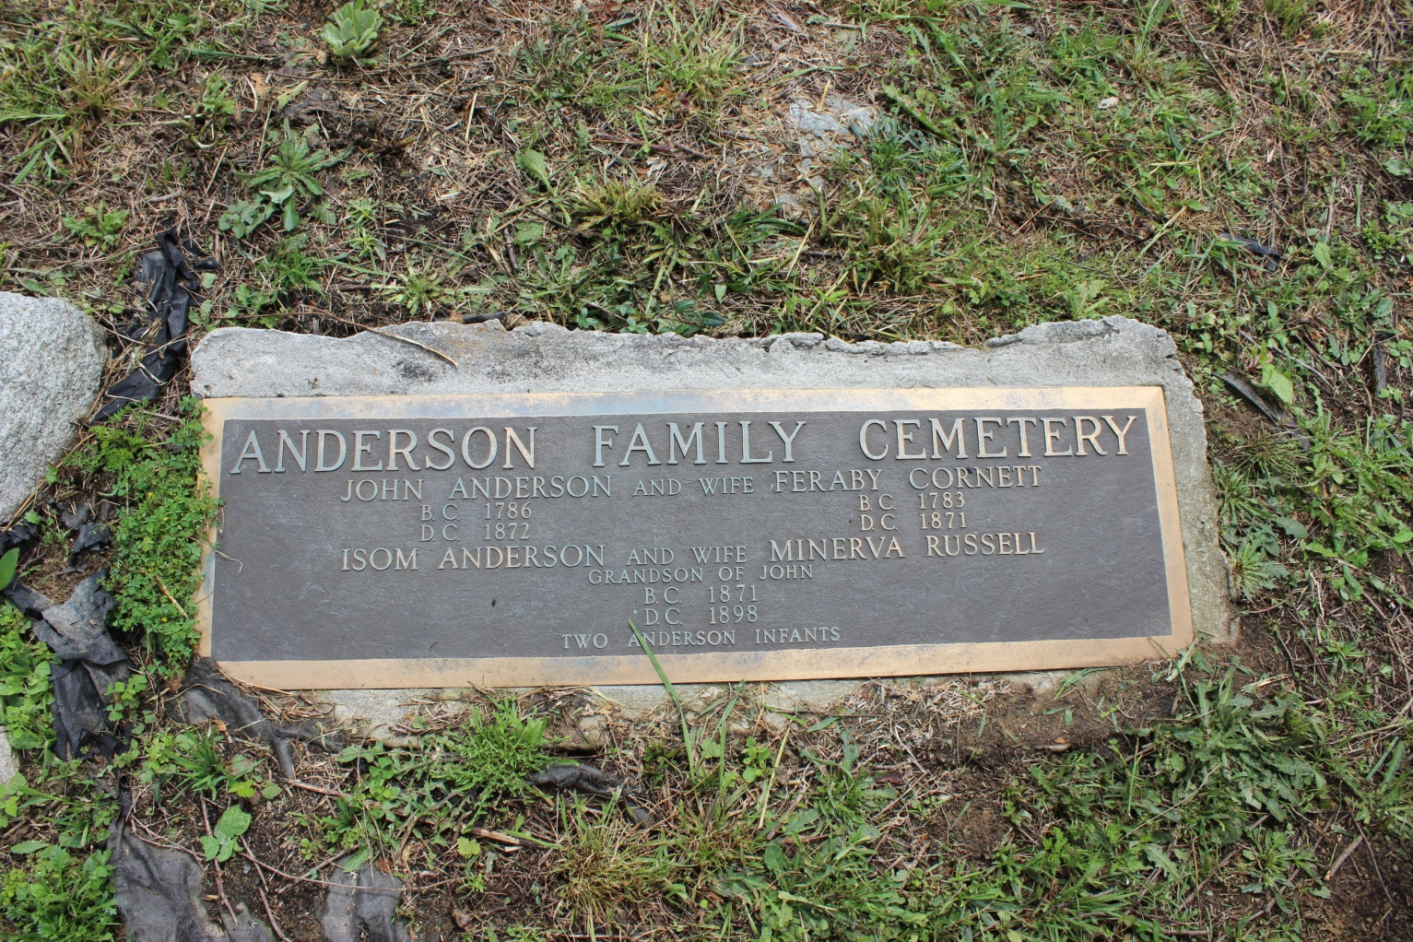
The brass plaque that remains in the John Anderson Cemetery behind Garnett Anderson’s house near Flat Ridge, Virginia that details the graves located here.
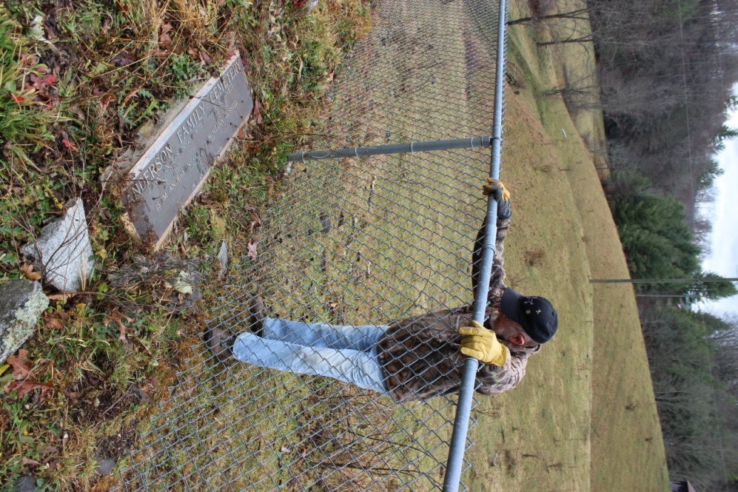
Andy Anderson reads the large marker in the John Anderson Cemetery (see above). Fox Creek flows at the edge of the field shown in the upper left of the photo with the forest just on the opposite (south) bank. The Anderson Mill was located less than one quarter mile upstream from the section of Fox Creek shown in the photo.

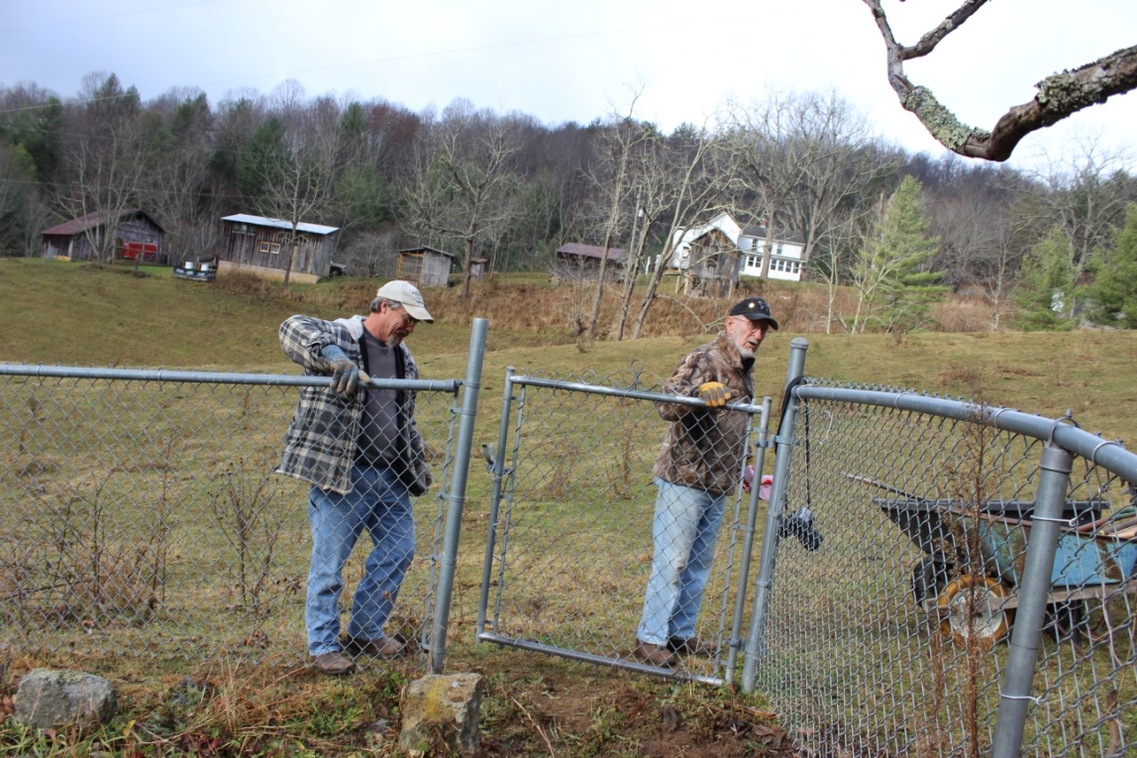
Chris Stevens (left), owner of the Garnett Anderson house, and Andy Anderson at the gate to the cemetery. The Garnett Anderson house and some of the out buildings are visible in the background. Chris and his wife, Leslie, have done a remarkable job of bringing the farm back to life in the past year. They have a beautiful garden, four happy dogs, lots of chickens, and two hives of bees (visible at the left end of the 2nd gray shed from the left). Chris and Leslie have even revived the “Morningside Farm” brand that Garnett introduced many years ago. The Stevens’ sell fresh eggs and honey under the Morningside Farm label.
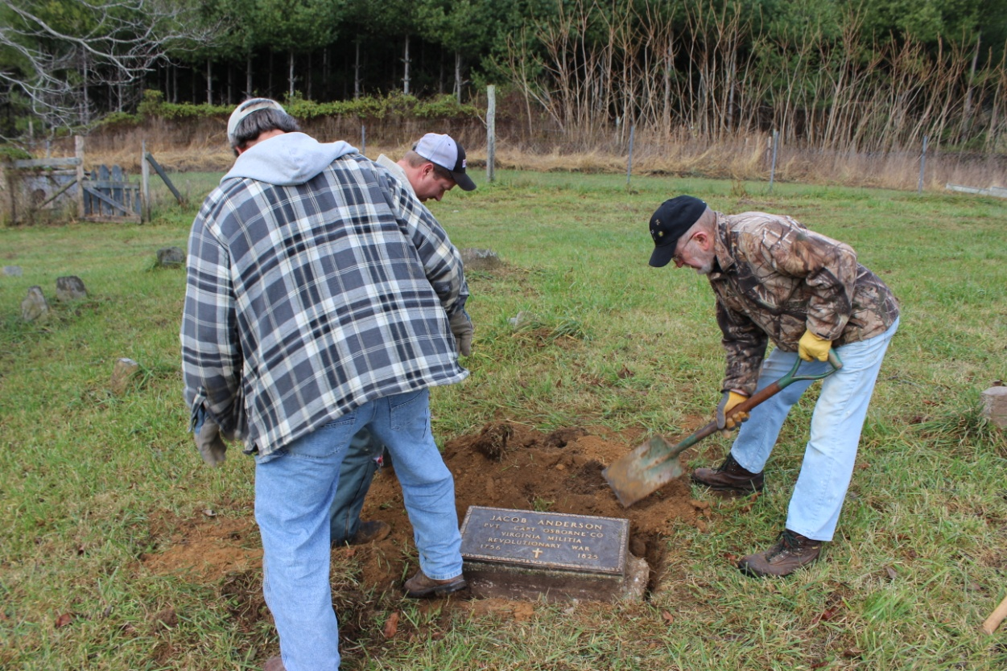
Chris, Andy and Jason Funk (center) replace dirt around the freshly placed Jacob Anderson marker. The Jacob Anderson Cemetery is located on Jason’s property and contains three rows of graves – approximately two dozen graves in all. It is difficult to get an exact count since the graves are marked with “field stones” and some may be missing after nearly 200 years. We suspect that Jacob’s grave is one located near the highest point on the hill, as was the custom at that time.

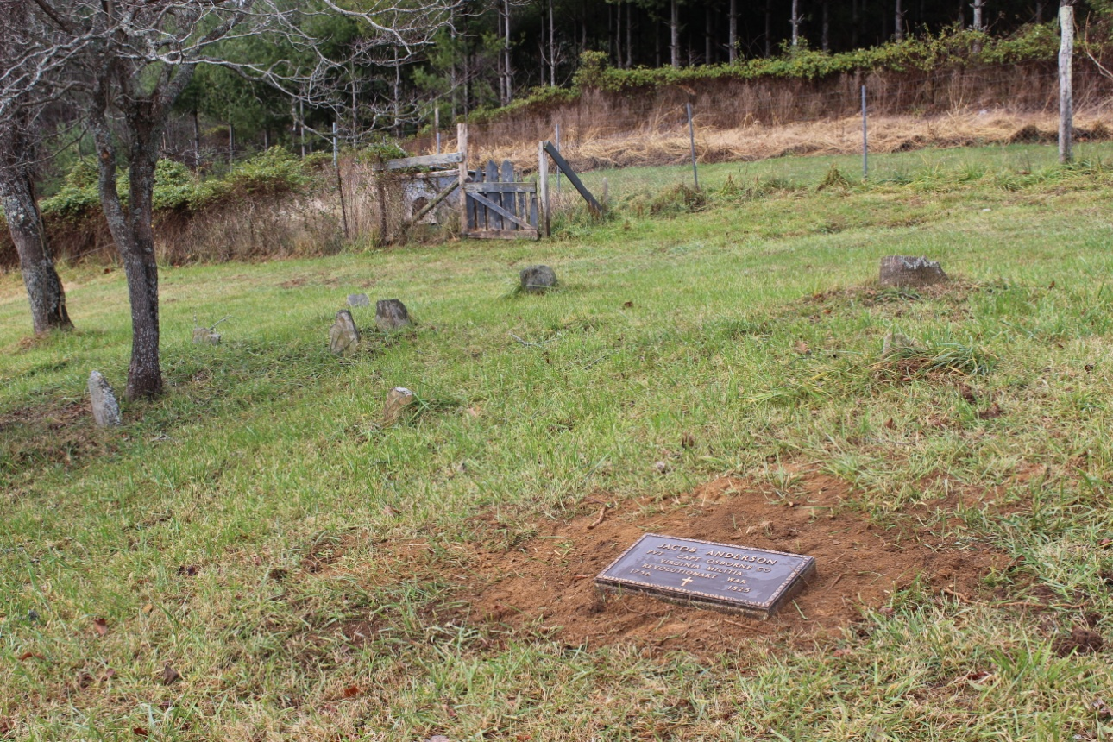
The new location of the Jacob Anderson plaque. There are several Anderson and Hash graves in this family cemetery. Some of the field stone markers are visible in the background. Jason and his wife Amanda do a terrific job of taking care of this cemetery along with the Central Cemetery. Both cemeteries are mowed and well groomed all year long thanks to their hard work.

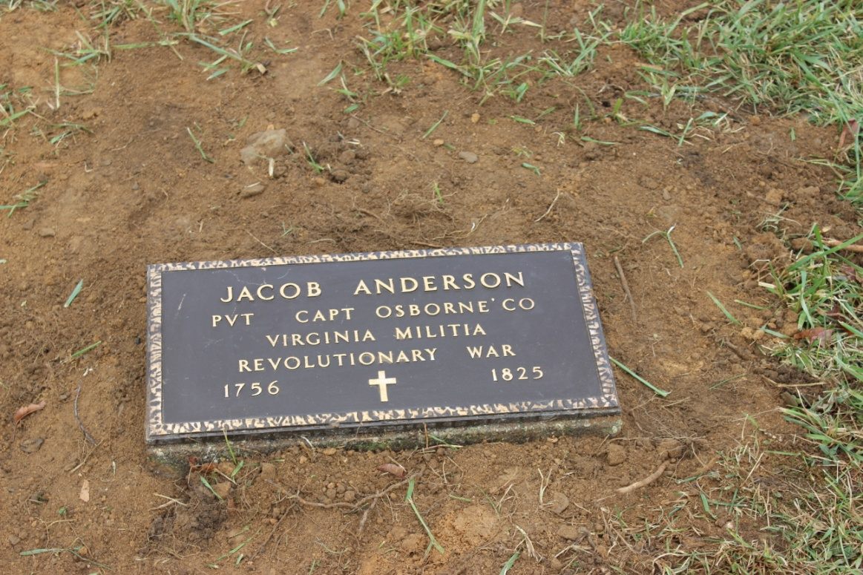
Saturday, November 23, 2013 was a great day! Thanks to Andy Anderson, Chris Stevens, and Jason Funk for all of their hard work moving the marker to its proper location on this cool, late autumn morning. The base the brass plaque is embedded in was much more substantial that we suspected so the job was a little bigger than expected. I am happy to report that after more than 30 years the task is finally complete. Jacob is Andy’s and my great-great-great-great grandfather

